Jihad Aravassery
#Azure Certified Architect +971 50 7124261, jihadaj@yahoo.com
Location Address: Al Ain (24° 12' 27.0000'' N and 55° 44' 40.9920'' E.), United Arab Emirates (UAE)
profile summary
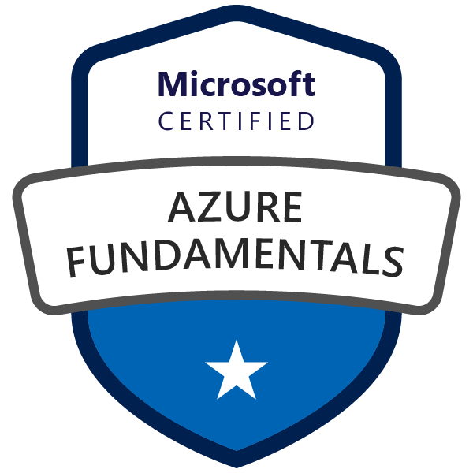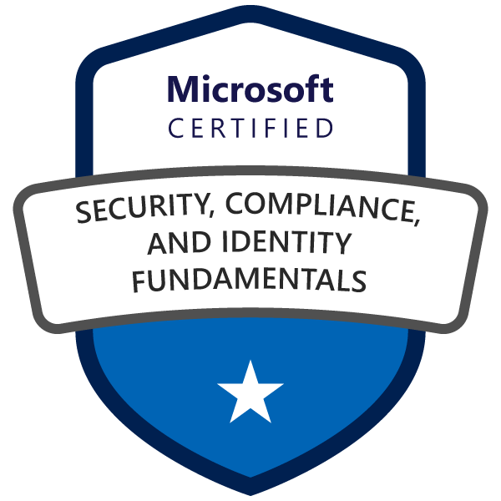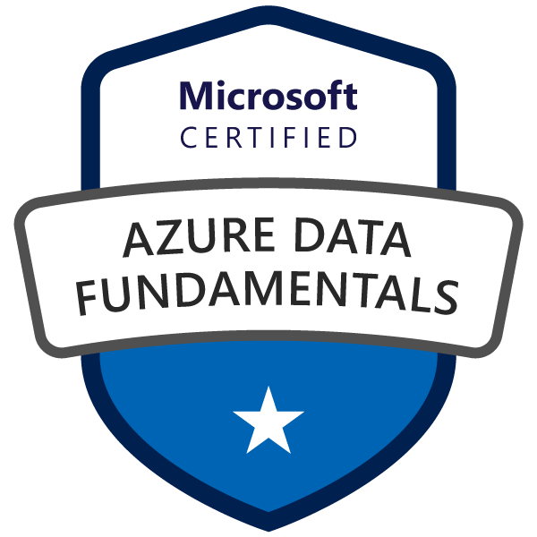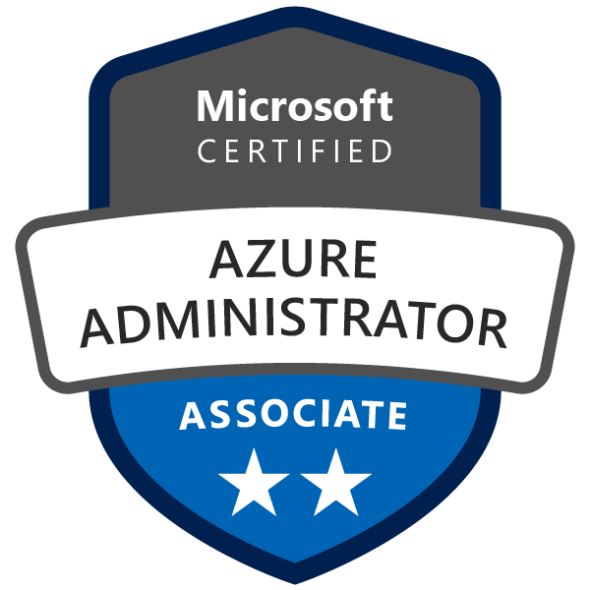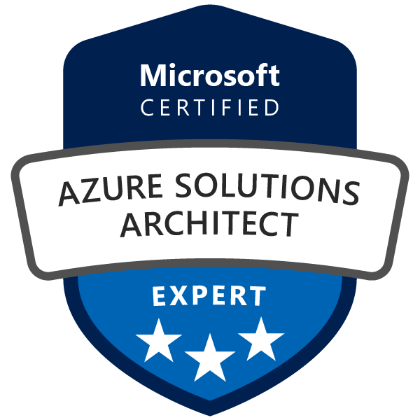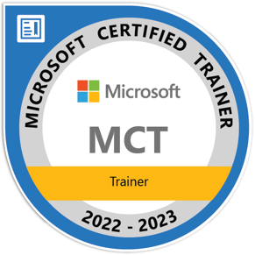

My Transcript : https://docs.microsoft.com/en-in/users/jihadaj/transcript/v0r85tm432e1w2r
My LinkedIn : https://www.linkedin.com/in/jihadaj/
- Microsoft Azure Certified – Solutions Architect (AZ 305), Administrator (AZ 104), Data fundamentals (DP-900), Security Compliance and Identity (SC-900) and Microsoft Certified Trainer
- Experience with core Microsoft technologies and services, including Azure (IaaS, PAAS),
Microsoft 365, Active Directory, Windows Servers, Hybrid Environment, Privileged Identity Management
- Microsoft Azure services such as Azure AD, Azure Storage, Azure SQL Database, Azure Web App, Azure Networking technologies (ExpressRoute, VPN, Virtual Networks, Network Security Groups, Traffic Manager, Azure Front Door, Azure Firewall.)
- Microsoft PaaS Data Services like Azure Synapse Analytics, Azure Data Lake, Azure Data Bricks and Azure Data Factory
- Experience optimizing cost/capacity ratios, monitoring, and scaling of Azure Cloud Services
- Knowledge of cloud security controls including tenant isolation, encryption at rest, encryption in transit, key management, vulnerability assessments, application firewalls, SIEM, etc.
- Robust knowledge and Experience of working with ITIL processes and ISO 27001 security practices
- Experience in enabling SharePoint for on-premises hosting, load balancing and database clustering to ensure high availability for critical-uptime systems.
- On prem Database Administration skills include setting High Availability (HA) , Disaster Recovery (DR), Always On with SQL Server 2014 & 2016, 2019
- Administration and configuration of Web servers, like IIS, Ngnix, Apache and application servers,
- Content Management Systems (CMS) like OmniUpdate, WordPress and various portals like SharePoint and Liferay
Educational Qualifications
Microsoft Certified Trainer Microsoft 2022
Master of Science in Information Technology,
sikkim manippal University – INDIA, 2009

Bachelor of Science in Computer Science,
CALICUT University – INDIA, 2001

soft Skills
- Good communication skills and sound aptitude in understanding business logic to provide optimal solutions.
- Project management skills for leading a team.
- Interpersonal and communication skills with an ability to interact at all levels.
- Strives to expand and acquire new knowledge and experiences.
- Quick learner, motivated, and work well with team members and under pressure.
Technical Skills
- Microsoft Azure , AWS  - Data Factory, Data Bricks, Azure Synapsis  - SharePoint Portal 2016 & 2019  - SQL Server 2014 ,2016 & 2019  - Java, Web Application Firewall  - Webservers like IIS, Nginx, Apache  - Virtualization, Datacenter Integration  - Server Management, LAN setups  - CMS like WordPress, Joomla & Omni Update | - Azure Kubernetes (AKS), Docker, Terraform  - Liferay Portal, SharePoint Portal  - Tools such as MS Project, Visio  - CentOS, Mac OS, Windows Servers  - GitHub, CI/CD, Pipelines  - ITSM tools like ServiceNow and Service Desk
training
- Azure Administration (AZ 104), Azure Machine Learning (AI-900), Azure Dev Ops (AZ 400), Azure Technical Architect (AZ 305), Azure Data Fundamentals (AZ 900), Azure Security Compliance and Identity (SC-900)
- Microsoft SharePoint Administration 2019
- Advanced SharePoint trouble Shooting and performance (From Microsoft)
- Microsoft Training for Administration of SQL Server 2014 And SQL Server 206
- ServiceNow, Service Desk Training

